Eivind Lervik

eivind.lervik@outlook.com

Summary

This document describes the different costs related to do development of the game Altreal. This includes both costs related to app-development and sever / database.

Development Costs

Investigation of costs related to developing Altreal

Content

1. Abstract 2

2. Application Development Costs 2

2.1. Unity 2

2.2. Apple PC 2

2.3. Apple Development License 2

2.4. Autodesk Maya LT 3

2.5. Photoshop 3

2.6. Git 3

2.7. Total 3

3. Server Development Costs 4

3.1. Hosting 4

4. Database Development Costs 4

3.1. Hosting 4

5. Website Development Costs 4

3.1. Hosting 4

6. Other Costs 4

6.1. Work Email 4

6.2. Trello 4

7. Summary 4

# 1. Abstract

As previously described, this document will be a guiding document for estimating costs and budgets. Some of the described costs below are estimates, some are foreseen costs, and some are actual costs.

# 2. Application Development Costs

Application development need both physical equipment and software. The costs are therefore categorized by sub-fields.

## 2.1. Unity

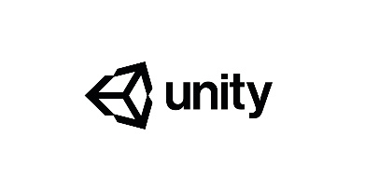

The game-engine unity have a license-cost of $35 per month. This cost is per developer. I estimate that only one license is necessary, because only one Unity-developer is needed at the current time. It is also important to note that as long as we do not earn money, we will not need a license for Unity. If our annual income surpasses $200.000, we will need to buy another license at $125.

## 2.2. Apple PC

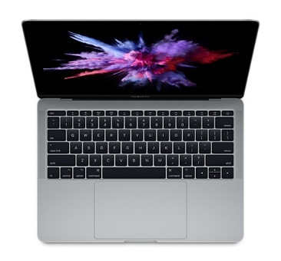

An Apple PC is needed for iOS-development. Costs may vary. Most ideally, we could buy a MacBook Pro (13 inch) for 14.990kr. A laptop is the way to go, due to movability. Alternatively, we could buy a second-hand Mac.

## 2.3. Apple Development License

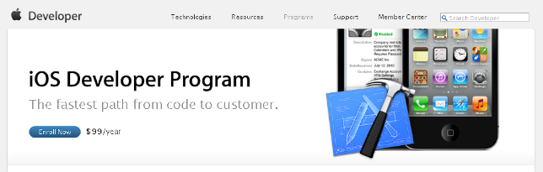

We will need a development license to be able to develop iOS apps. This is an annual cost of $99

## 2.4. Autodesk Maya LT



Modelling software to create models. As long as we don’t earn money, we don’t need the license. However, we will need one once we start earning money. This will cost $36,30 monthly.

## 2.5. Photoshop



A necessary tool to do game development. Here, I estimate at least two licenses. One for Eivind and one for Michelle. Maybe Hana also need one. Best plan here is to have two "Photo"-licenses (2X 117,50kr) and one "All applications"(590kr). This is to gain access to Premiere, Dreamweaver and Animate.

## 2.6. Git



A version control system for code and assets. If we choose the team option, we get it for $9 per person. We need the paid version because of protecting our product.

## 2.7. Total

This is the total monthly cost for application development.

|  |  |  |  |  |
| --- | --- | --- | --- | --- |
| **Item** | **Before Earning Money** | **When Earning Money** | **Required** | **Year** |
| Unity | 0kr | 270kr | Yes | 1 |
| Apple Developer License | 63,50kr | 63,50kr | Yes | 2 |
| Autodesk Maya LT | 0kr | 280kr | Yes | 1 |
| Photoshop (1) | 117,50kr | 117,50kr | Yes | 1 |
| Photoshop (2) | 117,50kr | 117,50kr | No | 1 |
| Adobe All | 590kr | 590kr | No | 1 |
| GitHub | 4 X 70kr | 4 X 70kr | Yes | 1 |
|  |  |  |  |  |
| **TOTAL YEAR 1 (ONLY)** | **397,50kr** | **947,50kr** | **Only** | **1** |
| **TOTAL YEAR 1 (ALL)** | **1105kr** | **1655kr** | **All** | **1** |
| **TOTAL YEAR 2 (ONLY)** | **461kr** | **1011kr** | **Only** | **2** |
| **TOTAL YEAR 2 (ALL)** | **1168,50kr** | **1718,50kr** | **All** | **2** |

This is the total one-off costs

|  |  |  |  |  |
| --- | --- | --- | --- | --- |
| **Item** | **Before Earning Money** | **When Earning Money** | **Required** | **Year** |
| Apple PC | 14990kr | 14990kr | Yes | 2 |
|  |  |  |  |  |
| **TOTAL** | **14990kr** | **14990kr** | **All** | **2** |

# 3. Server Development Costs

XXX

## 3.1. Hosting

XXX

# 4. Database Development Costs

XXX

## 3.1. Hosting

XXX

# 5. Website Development Costs

XXX

## 3.1. Hosting

XXX

# 6. Other Costs

## 6.1. Work Email

We will need five new email addresses for Altreal-related work. One official and one for each of us. Estimated cost is not yet set, and will vary on how much server / domain will cost.

## 6.2. Trello

  
Task-software. Basic is free.

# 7. Summary

XXX